-->

[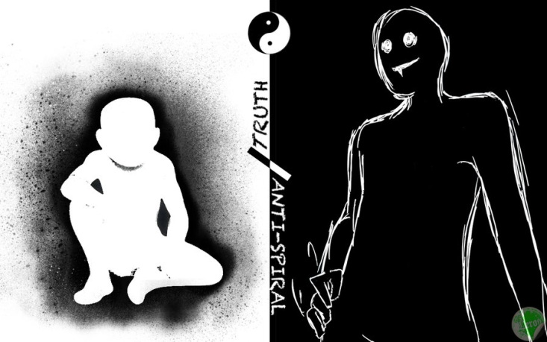](http://fc07.deviantart.net/fs71/i/2010/082/d/6/the_Truth_and_the_Anti_Spiral_by_leroyL.jpg)

Blindfolded by the darkness of a moonless night, I slipped into an unnamed alley in a bid to find something of which, I had never been seeker. It was curiosity, just like the other day when I had heard some people use the word. *‘I’ve been touched/ hurt/… in the****soul****’*and things like that. It is something that I haven’t quite felt in mine (soul).

So, I lured myself into that alley and made sure I left no trace on the ground, no footsteps. Walked on paved grounds, without light and support of the confining walls. All I could feel was the spiraling of the steps and the descent. I lost count of time and sensation of direction. I was just going down, and down, into a dark place. I sensed liquid down there, flowing, it was in the air. Yet I found none.

After a while I was parched, though moisture was all around, humid, deliquescent, and a melodic turbulence. I found nothing, no soul, no elixir, only tiredness. I backed down. I returned.

But while I returned, I felt light, because if it exists, it is still white. Unstained, too deep for me to seek, for now. And if it doesn’t, I’ve never had anything worthwhile to loose, eh? So, I return to a place where I wear a blindfold of blinding lights.